Create an AWS deployment diagram for the React and Java springboot application with the below details 1> Backend service is named 'credit-begin' Service is a micro service and java springboot REST based API with JWT token handling 2> provides the capability to UI for displaying credit deal for bankers 3> exposes API for UI and other internal clients 4> implements authentication using okta 5> implements authorization using OKTA JWT token 6> has eternal dependency on deal-service, worker-service and item-service 7> has dependency on 'credit-orchestration-service' domain, and 'credit-data-service' for JDBC8> implements logging using SLF4j9> Has Service Level Agreement for Availability 98%, throughput should be under 10 seconds

###### **ChatGPT said:**

To create an AWS deployment diagram for the credit-begin service, a microservice-based application with a React frontend and Java Spring Boot backend, we can use the following components:

### **Components Overview:**

1. **Frontend (React)**
   * **Amazon S3**: Hosts the static content (HTML, CSS, JS) of the React app.
   * **Amazon CloudFront**: Distributes the React app globally with low latency using the content delivery network (CDN).
2. **Backend (Java Spring Boot - credit-begin Service)**
   * **Amazon API Gateway**: Acts as the entry point for API requests to the credit-begin service.
   * **AWS Lambda or Elastic Beanstalk**: Hosts the Java Spring Boot application. Elastic Beanstalk is more common for hosting applications with specific frameworks like Spring Boot.
   * **Amazon RDS**: For the credit-data-service, which uses JDBC for database access.
   * **Amazon SQS**: For asynchronous communication, if needed, between credit-begin and dependent services like deal-service, worker-service, and item-service.
   * **Amazon CloudWatch**: For logging and monitoring, integrating with SLF4J logs.
   * **Amazon Cognito or Okta**: For user authentication and authorization, integrating with Okta JWT tokens.
   * **Amazon IAM**: For managing roles and permissions within AWS.
3. **External Dependencies**
   * **VPC Peering/Transit Gateway**: If deal-service, worker-service, and item-service are external services within different VPCs or networks.
   * **AWS Direct Connect**: For secure, private connectivity to external services if they are on-premises or in a different cloud.
4. **Additional Components**
   * **Elastic Load Balancer (ELB)**: Distributes traffic across multiple instances of the Spring Boot application.
   * **Auto Scaling Group**: Ensures availability and performance by scaling the application based on load.
   * **AWS Route 53**: Manages DNS and routes traffic to CloudFront.
5. **Service Level Agreement**
   * **Amazon CloudWatch Alarms**: To monitor uptime and response time, ensuring that SLAs are met.

### **Deployment Diagram:**

1. **Client Side**
   * User accesses the **React app** hosted on **S3** through **CloudFront**.
2. **API Gateway**
   * The React app makes API calls to **Amazon API Gateway**.
3. **Backend Processing**
   * **API Gateway** routes requests to the **Elastic Beanstalk** (hosting credit-begin service).
   * **Elastic Beanstalk** (Java Spring Boot):  
     + Authenticates requests using **Okta JWT tokens**.
     + Queries the **Amazon RDS** database via the credit-data-service.
     + Interacts with other microservices (deal-service, worker-service, item-service) using APIs or **SQS** for messaging.
     + Communicates with the **credit-orchestration-service** domain.
4. **Monitoring and Logging**
   * Logs and performance metrics are collected by **Amazon CloudWatch**.
5. **Security and Access Control**
   * **IAM roles** ensure that each service and user has the correct permissions.
6. **Scaling and Availability**
   * **ELB** distributes incoming traffic across multiple instances of the credit-begin service.
   * **Auto Scaling** adjusts the number of instances based on demand.
   * **CloudWatch Alarms** monitor availability and throughput to ensure they meet the SLA of 98% availability and under 10 seconds throughput.

This structure ensures scalability, security, and high availability for the credit-begin service, aligning with the given requirements.

Would you like me to create a visual diagram for this architecture?

##### **You said:**

yes pls

###### **ChatGPT said:**

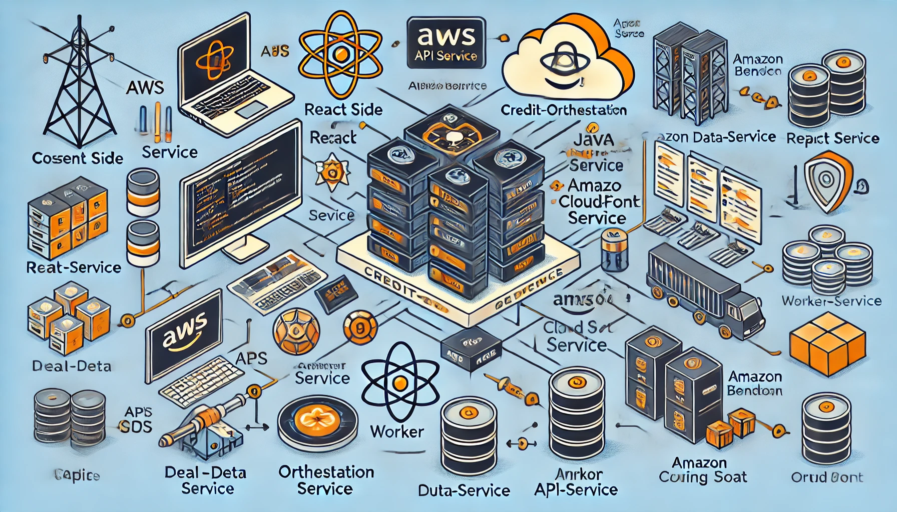

Made with the old version of image generation. New images [coming soon](https://openai.com/index/introducing-4o-image-generation/).

Here is the AWS deployment diagram for the credit-begin service and React application. It illustrates the architecture components and their interactions, as described earlier.

##### **You said:**

Change it to Azure deployment diagram?

###### **ChatGPT said:**

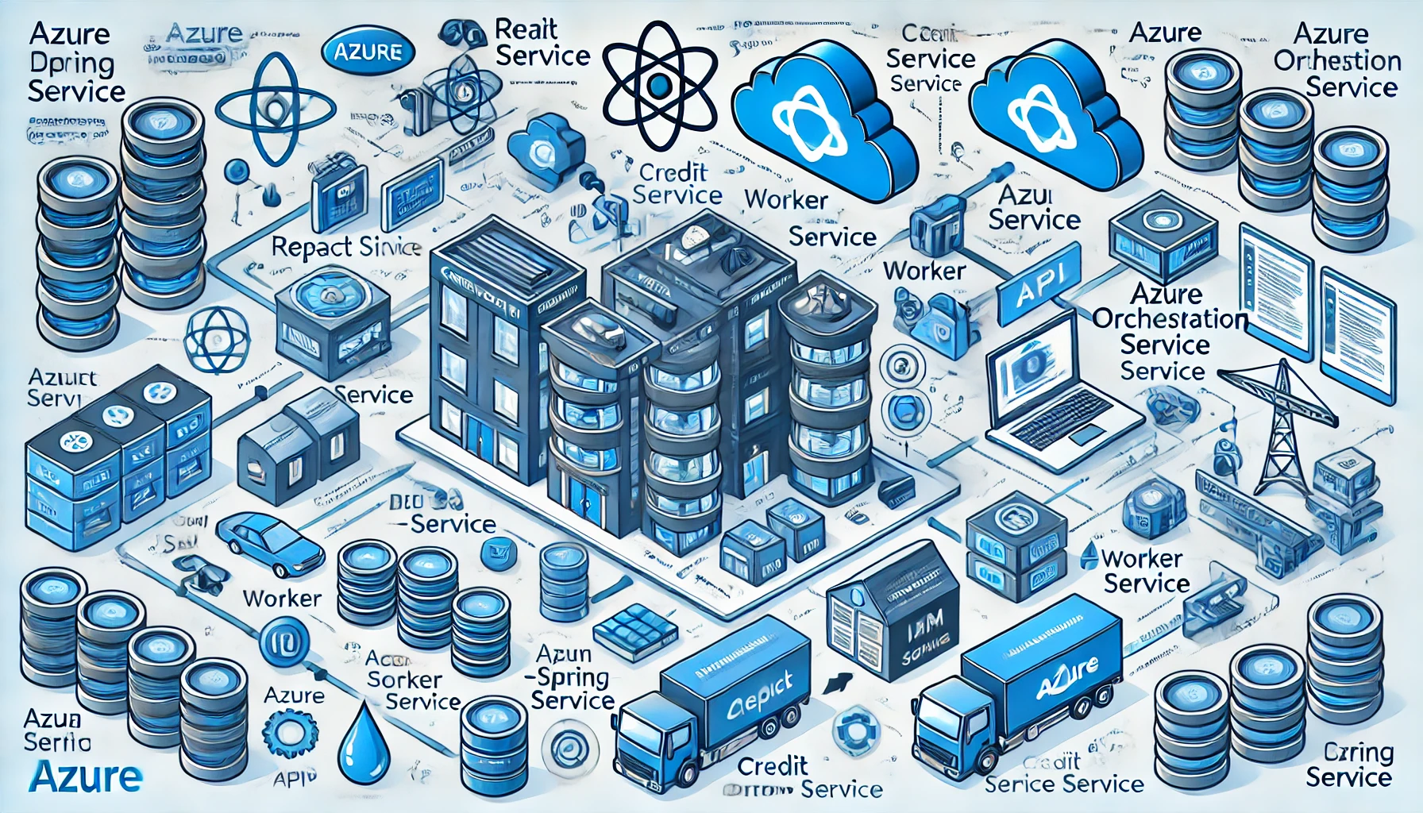

Made with the old version of image generation. New images [coming soon](https://openai.com/index/introducing-4o-image-generation/).

Here is the Azure deployment diagram for the credit-begin service and React application, reflecting the components and architecture described earlier.

##### **You said:**

Can you create a simple flow diagram?

###### **ChatGPT said:**

To create a simple flow diagram for the deployment of the credit-begin service and React application, I'll outline the key steps and interactions in a more streamlined manner.

### **Flow Diagram Components:**

1. **User Interaction**:  
   * User interacts with the **React UI** hosted on **Azure Blob Storage**.
   * Requests are routed through **Azure CDN** for faster delivery.
2. **API Request**:  
   * React app sends API requests to **Azure API Management**.
3. **Backend Processing**:  
   * **Azure API Management** forwards the request to the **Azure App Service** hosting the credit-begin service.
   * The service performs authentication using **Azure AD B2C** with Okta JWT tokens.
   * Queries are made to **Azure SQL Database** via the credit-data-service.
   * External services like **deal-service**, **worker-service**, and **item-service** are called via APIs or **Azure Service Bus** for messaging.
   * Data is orchestrated through **credit-orchestration-service**.
4. **Logging and Monitoring**:  
   * Logs and metrics are captured by **Azure Monitor**.
5. **Security and Scaling**:  
   * **Azure Load Balancer** distributes traffic.
   * **Azure Autoscale** adjusts resources as needed.
   * Alerts are set in **Azure Monitor** to maintain SLAs.

This flow diagram simplifies the interactions and key components, emphasizing the overall workflow. Would you like me to create a visual representation of this flow diagram?

##### **You said:**

yes

###### **ChatGPT said:**

It seems like I can’t generate any more images right now. Please try again later. If you need further assistance or another type of help, feel free to ask!

##### **You said:**

Can you create a visual representation of this flow diagram?

###### **ChatGPT said:**

I can create a visual representation of the flow diagram using descriptive text to guide you in visualizing it.

### **Simple Flow Diagram Representation:**

1. **User Interaction**:  
   * **User** → **Azure CDN** → **Azure Blob Storage (React UI)**
2. **API Request**:  
   * **React UI** → **Azure API Management**
3. **Backend Processing**:  
   * **Azure API Management** → **Azure App Service (credit-begin service)** → **Azure AD B2C (Authentication)** → **Azure SQL Database (credit-data-service)**
   * **Azure App Service** ↔ **deal-service / worker-service / item-service (via APIs/Azure Service Bus)**
   * **Azure App Service** → **credit-orchestration-service**
4. **Logging and Monitoring**:  
   * **Azure App Service** → **Azure Monitor (Logs/Alerts)**
5. **Security and Scaling**:  
   * **Azure App Service** ↔ **Azure Load Balancer / Azure Autoscale**
   * **Azure Monitor** monitors and ensures **SLAs**.

### **Flow Explanation:**

* **Arrows** represent the direction of data flow.
* **Interaction Points** include the user, API management, backend services, and monitoring tools.
* **External Dependencies** are indicated by two-way arrows between the credit-begin service and external services (deal-service, worker-service, item-service).

This diagram can be drawn using flowchart tools like Lucidchart, Visio, or even by hand for a quick sketch. If you want a tool-based visual guide or more assistance, feel free to ask!